## Robust ultra-high dimensional variable selection using group testing in Group-Correlated Data

**Wanru Guo1,2, Juan Xie1,2, Binbin Wang1,2, Weicong Chen3, Xiaoyi Lu4, Vipin Chaudhary3, Curtis Tatsuoka1,2**

**1Department of Biostatistics and Bioinformatics, University of Maryland, Baltimore, Baltimore, MD, USA**

**2Unversity of Maryland Marlene & Stewart Greenebaum Comprehensive Cancer Center, Baltimore, MD, USA**

**3Department of Computer and Data Sciences, Case Western Reserve University, Cleveland, OH, USA**

**4Department of Electrical & Computer Engineering, University of Florida, Gainesville, FL, USA**

**ABSTRACT**

**Background:** High-dimensional genomic data exhibit inherent group correlation structures that challenge conventional feature selection methods. Traditional approaches treat features as independent, while existing group-regularized methods require pre-specified pathways and suffer from high false discovery rates, computational complexity, and outlier sensitivity.

**Methods:** We introduce the **Dorfman screening framework**, a multi-stage hierarchical procedure that: (1) constructs data-driven groups via hierarchical clustering using sparse correlation (graphical LASSO) or robust measures (OGK covariance, Spearman); (2) performs two-stage hypothesis testing: global group-level tests followed by within-group variable screening; (3) refines selection via elastic net or adaptive elastic net; and (4) incorporates robustness through Huber-weighted regression and dynamic tree cutting for contaminated data.

**Results:** Simulations (n=200, p=500, 100 groups) show **Dorfman-Sparse-Adaptive-EN** excels in normal data (**F1 = 0.876, RMSE = 1.363**), with **Robust-OGK-Dorfman-Adaptive-EN** as the runner-up (**F1 = 0.843, RMSE = 1.679**). Under corrupted data with broken correlations, batch effects, and asymmetric noise, **Robust-OGK-Dorfman-Adaptive-EN** (**F1 = 0.818, RMSE = 5.249**) demonstrates a clear advantage, significantly outperforming classical Dorfman methods and all competitors including adaptive EN, EN, SIS-LASSO, and gAR2. Applied to GDSC RNA-seq data for trametinib response in NSCLC, robust Dorfman methods achieved superior predictive accuracy (**RMSE = 2.17–2.33**) and enriched selection of clinically relevant genes.

**Conclusions:** The Dorfman framework provides a robust, efficient solution for genomic biomarker discovery. **Robust-OGK-Dorfman-Adaptive-EN emerges as the method of choice**, performing competitively in normal scenarios while offering decisive improvements under realistic data contamination and non-normality. The framework is scalable to ultra-high dimensions (p=100,000) via block estimation and Bayesian optimization, ensuring applicability to next-generation genomic studies.

**Introduction**

High-dimensional biomedical data generated by modern platforms such as multi-omics profiling, high-resolution imaging, and electronic health records continue to expand rapidly in both scale and complexity. A central challenge in these settings is variable screening for regression modeling, where the number of candidate predictors (*p*) far exceeds the sample size (*n*) (Fan & Lv, 2008; Bühlmann & Van de Geer, 2011). In practice, only a small fraction of variables is truly associated with the outcome of interest, while the vast majority are irrelevant, resulting in a classic “needle-in-a-haystack” problem (Fan et al., 2009).

To address this challenge, a broad class of high-dimensional screening and selection methods has been developed, including sure independence screening (SIS), the LASSO, and the elastic net (Tibshirani, 1996; Zou & Hastie, 2005; Fan & Lv, 2008). SIS established the sure screening property, showing that marginal correlation–based screening can retain all relevant predictors with high probability even in ultra-high-dimensional regimes where log(p) = O(n ^alpha) for alpha belongs to (0,½) (Fan & Lv, 2008). These ideas motivated extensive development of both model-based and model-free screening procedures (Fan et al., 2009; Fan & Song, 2010; Wang, 2009; Li et al., 2012; He et al., 2013; Shao & Zhang, 2014; Zhao & Li, 2012). However, these approaches fundamentally operate on individual predictors and implicitly treat features as marginally independent.

Such assumptions are routinely violated in genomic and biomedical data, where genes and molecular features exhibit strong group-wise correlation structures driven by shared biological pathways, regulatory networks, and functional modules (Barabási et al., 2004; Subramanian et al., 2005). Ignoring these dependencies can lead to unstable feature selection and failure to recover biologically coherent signals in ultra-high-dimensional settings (Zou et al., 2005; Meinshausen & Bühlmann, 2010). Group-regularized extensions, including the group LASSO, sparse group LASSO, and group-based screening methods such as group SIS, AR2 and HOLP, have been proposed to address correlated predictors (Yuan & Lin, 2006; Huang et al., 2010; Simon et al., 2013; Qiu & Ahn, 2020). However, these methods rely on pre-specified group or pathway annotations, which are often incomplete, context-dependent, or unavailable, and can result in inflated false discovery rates when group definitions are misspecified (Jacob et al., 2009; Bühlmann et al., 2014). Moreover, group-based regularization can be computationally demanding in ultra-high dimensions and remains sensitive to outliers and distributional departures, limiting robustness in large-scale omics applications (Fan et al., 2012; Alfons et al., 2013).

Group testing provides an alternative paradigm for efficient screening under sparsity. Originally proposed by Dorfman (1943) in the context of infectious disease testing, group testing exploits low prevalence by pooling samples, allowing many negatives to be cleared with a single test and substantially reducing cost. When a pooled test is positive, follow-up individual testing is performed, yielding large efficiency gains in sparse settings. Modern extensions have incorporated probabilistic and Bayesian formulations that address practical challenges such as dilution effects and measurement error, further improving inferential performance in biomedical applications (Tatsuoka, Chen & Lu, 2022). These developments highlight the relevance of group testing principles for contemporary high-dimensional screening problems characterized by sparsity and noise.

Motivated by these ideas, we introduce the **Dorfman variable screening framework ~~for continuous outcome~~**, a computationally efficient multi-stage hierarchical procedure that adapts group testing principles to high-dimensional regression. The procedure first clusters genes into data-driven, biologically meaningful groups using hierarchical clustering based on Pearson correlation or sparse correlation estimated via the graphical LASSO, which induces sparsity in the inverse covariance matrix and stabilizes clustering in high dimensions (Friedman et al., 2008). Group-level global tests are then performed to identify candidate signal groups, followed by within-group individual variable screening for identified groups. A final regularized selection step using the elastic net or LASSO refines variable selection while accounting for residual correlation structure (Tibshirani, 1996; Zou & Hastie, 2005). Robust variants of the Dorfman framework further address outlier contamination by incorporating Huber-weighted regression throughout group testing and within-group screening (Huber, 1964), with groups determined by dynamic cut hierarchical clustering (Langfelder et al., 2008) using Spearman correlation or sparse correlation derived from an OGK (orthogonalized Gnanadesikan–Kettenring) covariance estimator (Oellerer & Croux, 2015). Together, in this modular structure, these methods provide a unified, scalable, and robust approach to screening grouped predictors in ultra-high-dimensional biomedical data, closely aligned with modern developments in group testing and Bayesian extensions accounting for noise and dilution effects (Tatsuoka, Chen & Lu, 2022). Focus here will be given to continuous outcomes in linear regression models, including when deviations from classical assumptions arise. Simulations are conducted that show the advantages of our proposed Dorfman-based framework, particularly in non-normal data settings. Finally, a real-data example is presented that illustrates how the methods are used to identify genes that predict IC50 for a MEK-inhibitor in non-small cell lung cancer with bulk RNA sequencing data.

2. Grouped variable screening

A key novel feature of our proposed framework for variable screening in ultra-high dimension is the use of group testing principles to screen groups of variables. In general, when pooled testing is possible, group testing is most effective when the target binary characteristic being testing for has low prevalence. The objective of variable screening is to identify all the variables that have “significant” association with the outcome variable in a regression model (relative to a target alpha). In variable screening using group testing, pooled tests are regression models comprised of subsets (“pools”) of variables. In our setting, pooled tests are viewed as “negative” based on global tests that compare null models (intercept only) versus models that include all the variables selected as a pool. If the global test rejects the null model, individual variable significance levels within the model fit are considered at selected alpha threshold. To encourage correct “positive” decisions, we first implement hierarchical clustering methods to create pools of correlated variables under the assumption that positive variables are likely to be correlated (e.g. genes belong in same pathway) and enhance power in rejecting the null model. Conversely, assuming that negative variables also cluster, selecting pools in this manner encourages low Type I error for the global test of the pool. This is the critical efficiency advantage of group testing, to efficiently identify negative variables through pooling. The selection of individual variables in among the respective pooled tests is inherently vulnerable to Type I errors due to multiple comparisons. Hence, a final stage of this process is to apply penalized regression methods on the collection of the individual variables that are selected from the positive pooled tests. Note that the penalized regression at this stage of the process is applied on a smaller set of variables than directly applying penalized regression on the complete set of candidate variables.

In sum, there are 4 major stages to this approach: 1) computing correlations among variables; 2) hierarchical clustering; 3) pooled testing of clusters through regression with the outcome variable; 4) penalized regression on variables identified as potentially positive from stage 3. The overall approach is outlined in Figure 1.

Note that the methodologies at each stage can be replaced without affecting the other stages. Hence, this approach can be viewed as modular, and we exploit this to adapt the approach to robust settings when the outcome variable is not normally distributed, or variables are skewed or have high kurtosis, or include outliers or influential points. We do this by employing approaches for 1) robust and sparse estimation of correlations; 2) dynamic cut approaches for hierarchical clustering; 3) Huber methods for robust regression; 4) using elastic net and adaptive elastic net approaches. This leads to a number of possible ways to conduct group testing for variable selection.

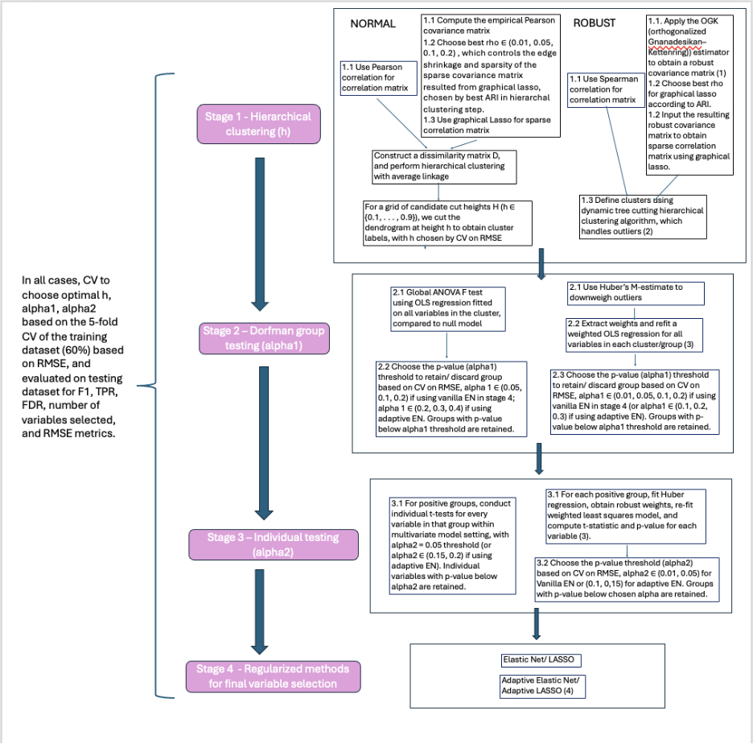

Figure 1. Entire workflows of Normal and Robust Dorfman Procedures.

2.1 Dorfman–Elastic Net/Adaptive EN with Pearson/Sparse Co-variance and Cross-Validated Cut Height



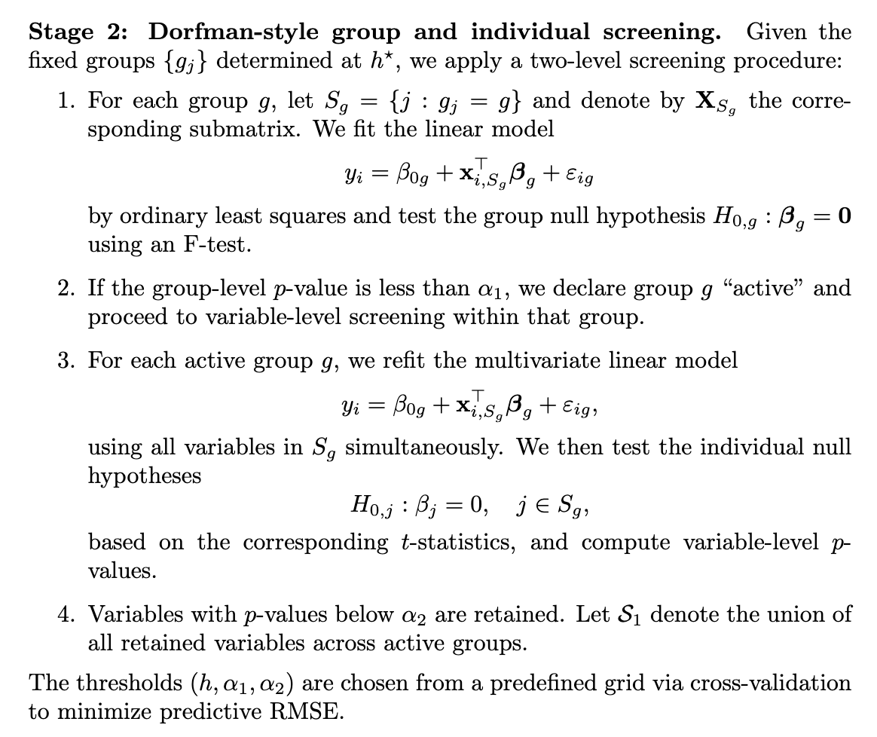

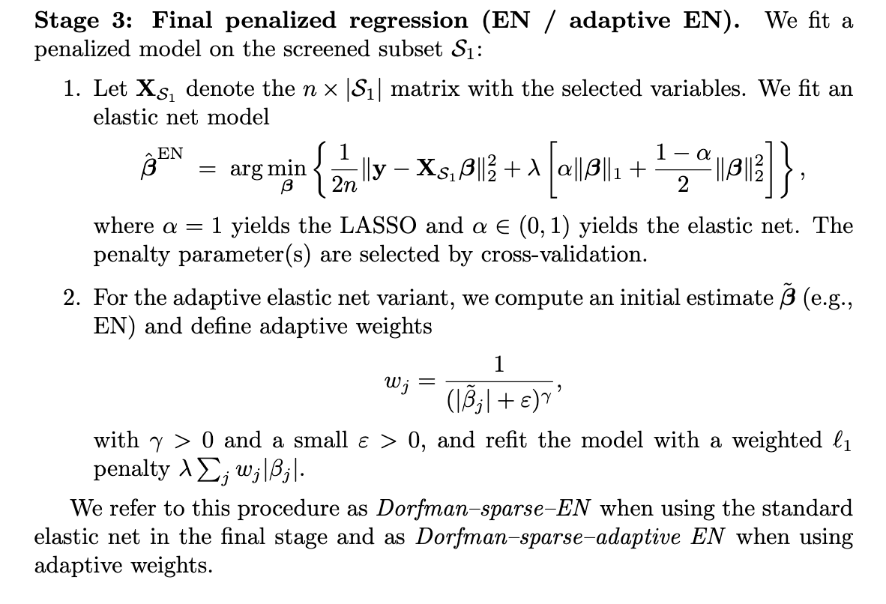

We refer to Option B of this procedure as Dorfman sparse EN when using the standard EN in the final stage, and Dorfman sparse adaptive EN when using adaptive EN in the final stage. And we refer to Option A as the classical Dorfman_EN in our method comparison. This entire procedure is summarized in Algorithm 1.



2.2 Robust Spearman/OGK–Huber Dorfman–EN/Adaptive EN with Spearman/Sparse Robust Covariance

To handle heavy-tailed noise, leverage points and contamination in the dependence structure, we consider a robust extension of the Dorfman–EN framework. This method combines (i) a robust high-dimensional covariance estimator based on the OGK approach, as implemented in Oellerer & Croux (2015), (ii) graphical lasso sparification, (iii) robust cluster-wise and variable-wise screening using Huber M-estimation, and (iv) a final elastic net (or adaptive elastic net) fit.





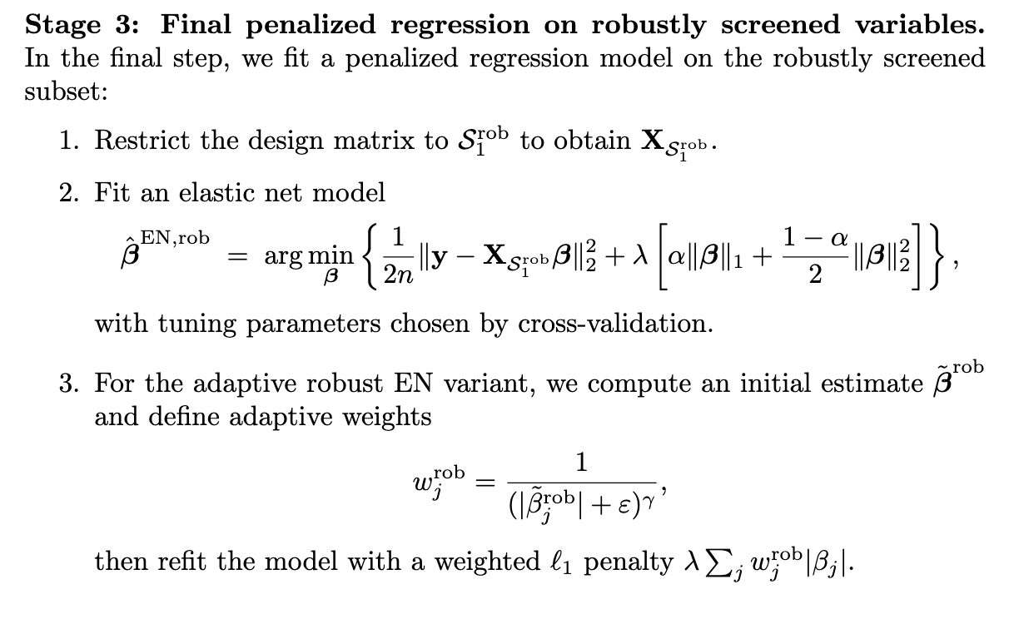

We refer to Option B of this procedure as Robust OGK Dorfman–EN when using the standard EN in the final stage and as Robust OGK Dorfman–adaptive EN when using adaptive weights, built on a robust sparse covariance structure following Oellerer & Croux (2015), and option A of this procedure as robust spearman Dorfman EN/ Adaptive EN. The entire procedure is summarized in Algorithm 2.



3. Numerical studies

Simulations settings

3.1 Normal case

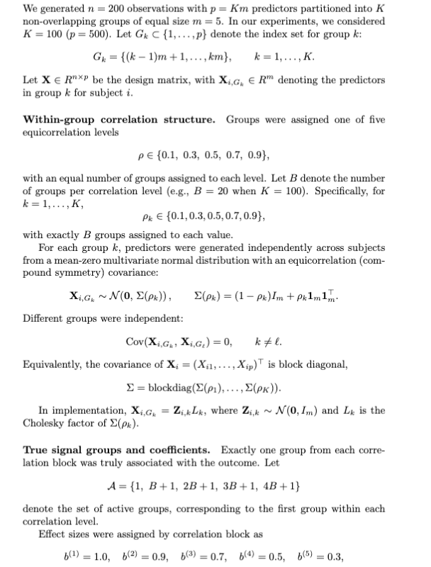

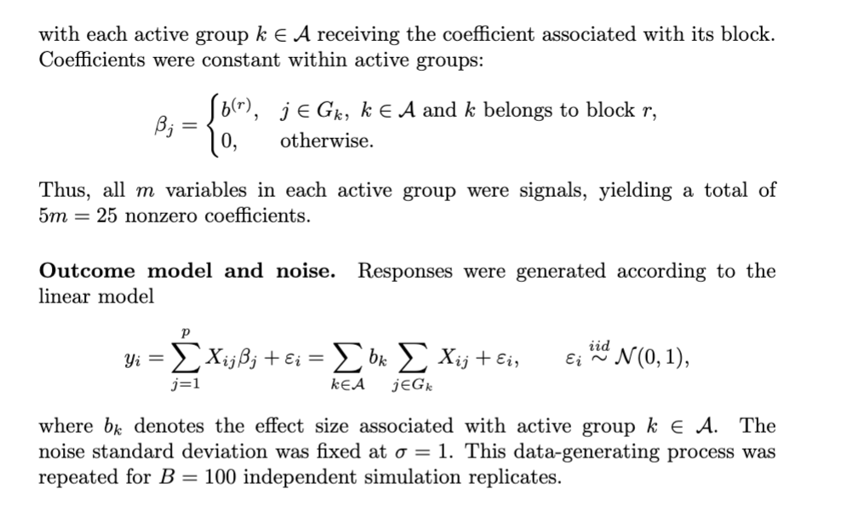

3.2 Robust (Contaminated) case

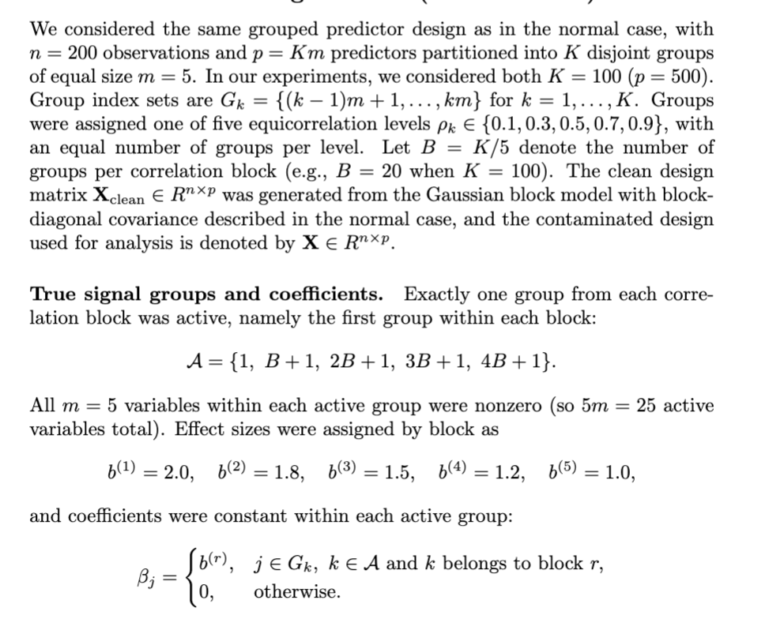

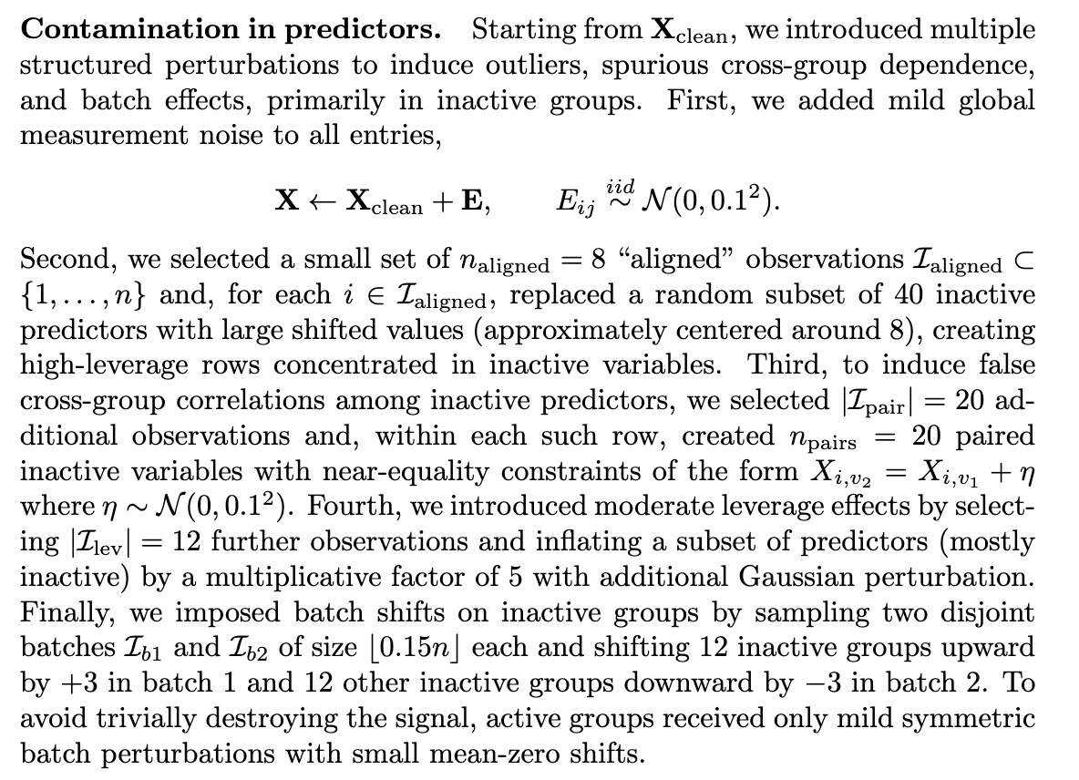

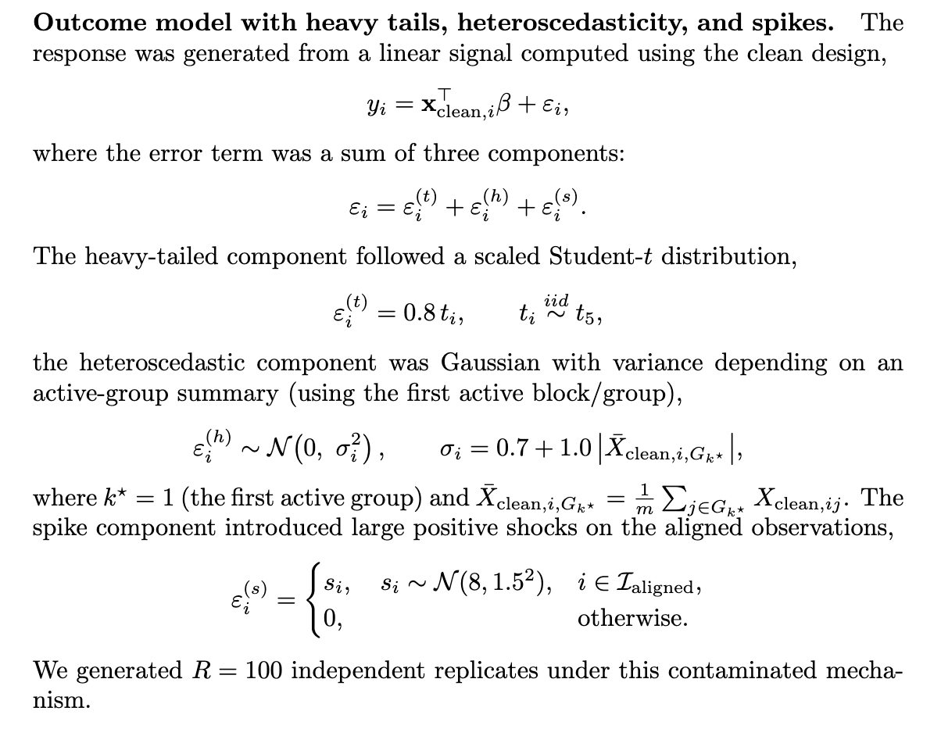

A visualization of the corruption is shown in Appendix A. Supplementary Fig 1.

3.3 Competitor methods (SIS-LASSO and Group AR2)

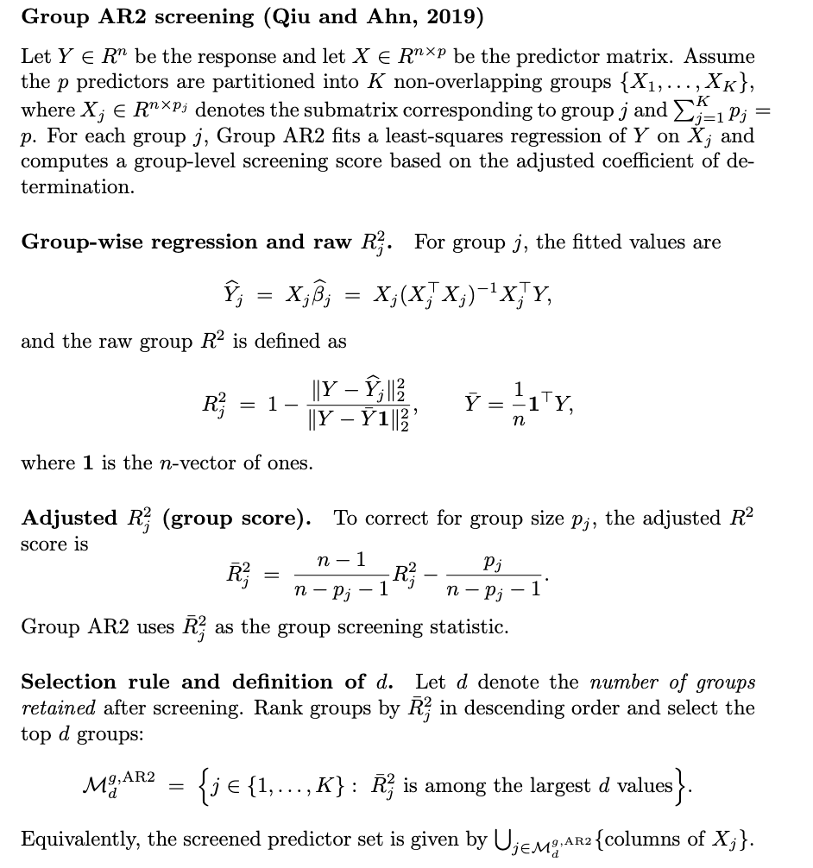

d is chosen by the common SIS rule 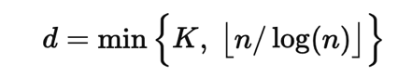(Qiu & Ahn, 2019), with pre-specified K=100 groups when p=500, and K=200 groups when p=1000.

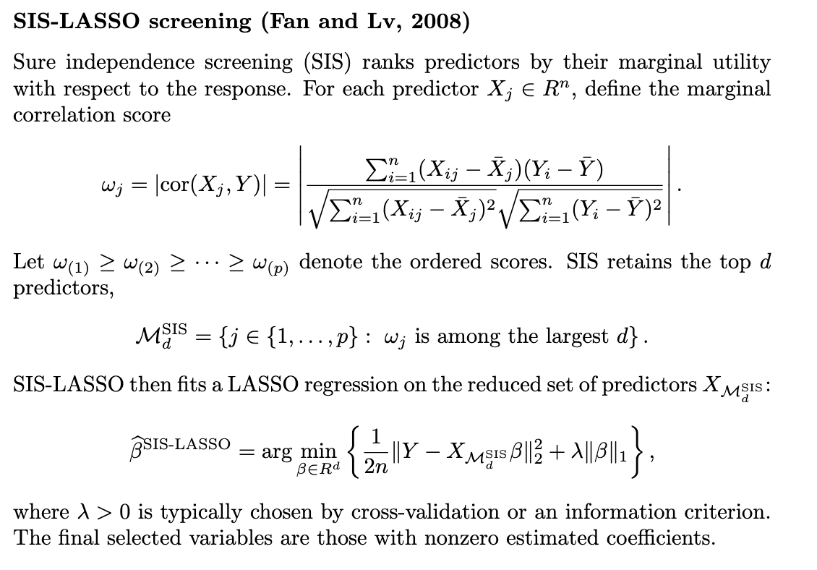Where d is determined by the asymptotic property d = n/log(n) (Fan & Lv, 2008).

**Table 1. Performance Metrics of methods under the normal scenario (p=500). Results are in mean (sd).**

|  |  |  |  |  |  |
| --- | --- | --- | --- | --- | --- |
| Method | Variables | TPR | FDR | F1 | RMSE |
| Dorfman_sparse_Adaptive_EN | 24.0 (1.7) | 0.858(0.045) | 0.102(0.082) | 0.876(0.058) | 1.363(0.241) |
| Robust_OGK_Dorfman_Adaptive_EN | 21.6 (3.6) | 0.787 (0.111) | 0.08(0.032) | 0.843 (0.082) | 1.679 (0.403) |
| Adaptive_EN | 28.1 (4.3) | 0.876 (0.042) | 0.205(0.125) | 0.829 (0.078) | 1.372 (0.154) |
| Dorfman_EN | 29.2 (2.6) | 0.871 (0.048) | 0.25 (0.068) | 0.804 (0.05) | 1.785 (0.258) |
| Group_AR2_gp_LASSO | 55.8 (12.3) | 0.993 (0.045) | 0.538 (0.105) | 0.776 (0.058) | 7.324 (1.105) |
| Robust_OGK_Dorfman_EN | 23.7 (3.1) | 0.751 (0.095) | 0.2 (0.103) | 0.772 (0.082) | 2.312 (0.412) |
| SIS_LASSO | 16.0(0) | 0.613 (0.02) | 0.042 (0.021) | 0.748 (0.024) | 2.871 (0.384) |
| EN | 52.9(11.1) | 0.947(0.04) | 0.532(0.116) | 0.619 (0.094) | 1.555 (0.244) |

***Normal scenario***. In the normal (uncontaminated) simulation setting, the proposed Dorfman-based screening procedures achieved the strongest overall performance by balancing sensitivity and false discovery control while selecting a moderate number of variables. In particular, **Dorfman_sparse_Adaptive_EN** produced the best results, with the highest average **F1 = 0.876**, strong sensitivity (**TPR = 0.858**), and a low false discovery rate (**FDR = 0.102**), while selecting only **24.0 variables** on average, also achieving the highest predictive power (lowest RMSE =1.363). On the other hand, we did notice a trend of robust methods under performing their non-robust counterpart, namely **Robust_Sparse_Dorfman_Adaptive_EN vs Sparse_dorfman_adaptive_EN (0.843 vs 0.876) and robust Dorfman_EN vs Dorfman_EN (0.772 vs 0.804), which is expected under normal conditions when linear assumptions hold. In contrast, adaptive EN showed competitive but weaker performance (0.829 vs 0.876) a**nd substantially higher false discovery rates (around **0.21**), double that of dorfman-sparse-adaptive EN. The non-adaptive Dorfman variants underperformed (**Dorfman_sparse_EN** and **Dorfman_EN**), although maintaining high sensitivity (**TPR = 0.871** for both), their higher false discovery rates (**0.241–0.250**) reduced overall F1 performance (**0.809** and **0.804**).

**Group_AR2** achieved near-perfect sensitivity (**TPR = 0.993**) but selected far more variables (**55.8**) and produced a high false discovery rate (**0.538**), suggesting that it tends to over-select and introduce many false positives. It is due to group_AR2_gp_LASSO selecting all variables in all positive groups in the first stage, while the second stage applies a group LASSO to all these variables selected (Qiu & Ahn, 2019), which in itself is known to have high false positive rates (Simon et al, 2013). *The finding that our Dorfman method outperforms gAR2 is exciting, as gAR2 was known as the best performer under independent groups, within group correlation scenario (one of six scenarios presented by Qiu & Ahn, 2019), better than group-SIS and group-HOLP.*

Similarly, vanilla **EN** selected very large models (**52.9 variables**) with high false discovery rates (both around **0.53**), leading to the lowest F1 scores (**0.619** and **0.615**). Finally, **SIS_LASSO** generated the sparsest solutions (**16.0 variables**) and the lowest false discovery rate (**0.042**), but its lower sensitivity (**TPR = 0.613**) limited its overall recovery performance (**F1 = 0.748**). *As noted, since SIS methods’ asymptotic property the d is predefined as n/log(n), along with the lasso penalty have limited and fixed the number of variables selected. It is expected that the performance will increase as n gets larger, however, we are eventually dealing with high-dimensional scenarios, where p>>n where its performance is extremely limited.* Overall, these results show that the adaptive sparse Dorfman procedure provide the best trade-off between selecting true signals and controlling false positives in the clean high-dimensional setting, and that it outperforms not only competitors, but also the robust variant.

**Table 2. Performance Metrics of methods under the robust (contaminated) scenario (p=500). Results are in mean (sd).**

|  |  |  |  |  |  |
| --- | --- | --- | --- | --- | --- |
| Method | Variables | TPR | FDR | F1 | RMSE |
| Robust_OGK_Dorfman_Adaptive_EN | 22.5 (2.8) | 0.778 (0.077) | 0.132 (0.071) | 0.818 (0.054) | 5.249(1.081) |
| Robust_OGK_Dorfman_EN | 23.6 (2.3) | 0.796 (0.077) | 0.153 (0.088) | 0.819 (0.073) | 5.731(1.662) |
| Dorfman_sparse_Adaptive_EN | 20.5 (5.4) | 0.713 (0.168) | 0.109 (0.036) | 0.779 (0.127) | 7.368(2.614) |
| Dorfman_EN | 29 (3.7) | 0.869 (0.051) | 0.241 (0.095) | 0.807 (0.062) | 5.783(1.519) |
| group_AR2_gp_LASSO | 55.1 (11.7) | 0.991 (0.053) | 0.533 (0.098) | 0.778 (0.057) | 7.864 (1.314) |
| SIS_LASSO | 16 (0) | 0.625 (0.02) | 0.023 (0.032) | 0.763 (0.025) | 7.503(1.152) |
| Adaptive_EN | 30.9 (3.6) | 0.862 (0.052) | 0.296 (0.078) | 0.773 (0.053) | 5.325(0.809) |
| EN | 50.8 (10.6) | 0.949 (0.044) | 0.516 (0.092) | 0.635 (0.073) | 5.305 (0.758) |

**Table 3. Runtime statistics (mean(SD)) for top-performing Dorfman methods in comparison to competitors (secs).**

|  |  |  |
| --- | --- | --- |
| ***Method*** | ***Normal*** | ***Robust*** |
| Robust_OGK_Dorfman_Adaptive_EN | 4.084(0.261) | 5.124 (0.613) |
| Dorfman_sparse_Adaptive_EN | 55.702 (0.633) | 63.454 (1.269) |
| SIS_LASSO | 0.217(0.107) | 0.263 (0.122) |
| Adaptive_EN | 0.023 (0.009) | 0.022 (0.002) |
| EN | 0.013 (0.003) | 0.015 (0.004) |

***Corrupted scenario***. Under the contaminated (robust) scenario (Table 2), the proposed robust Dorfman variants achieved the strongest overall screening performance, yielding the highest average F1 scores while maintaining relatively low false discovery. In particular, **Robust_Sparse_Dorfman_EN** attained the best overall balance with **Avg_F1 = 0.819**, together with **Avg_TPR = 0.796** and **Avg_FDR = 0.153**, while selecting the number variables closest to the ground truth (**Avg_Vars = 23.6**). The **Robust_OGK_Dorfman_Adaptive_EN** method performed similarly well (**Avg_F1 = 0.818,** **Avg_TPR = 0.778**, **Avg_FDR = 0.132**, **Avg_Vars = 22.5**), with this method in particular yielding the lowest RMSE (5.249), meaning the highest predictive power. In this scenario, we can see clearly that the robust methods outperformed classical Dorfman approaches (Dorfman_sparse_Adaptive_EN and Dorfman-EN). This is exactly as expected in the robust scenario meaning our methods have high reliability. ***More interestingly,*** the Dorfman Sparse adaptive EN, which was known to perform the best in the normal case, performed significantly worse in the robust case, even underperformed Dorfman-EN (F1 score - 0.779 and 0.807 respectively, and RMSE 7.368 vs 5.783. *This further proves that graphical LASSO derived sparse precision matrices are statistically inconsistent under model misspecification in the robust case, emphasizing the utility of the OGK estimator for providing a contamination-resistant covariance input.*

**As seen in the normal case, Group_AR2_gp_LASSO** produced the **largest selected model** (**Avg_Vars = 55.1**) and achieved the **highest Avg_TPR = 0.991**, but suffered from substantially inflated false discovery (**Avg_FDR = 0.533**) and the worst predictive performance (**Avg_RMSE = 7.220**). This behavior is expected due to previous discussions, plus especially in this case when contamination induces spurious cross-group dependence, and when group definitions are imperfect or when outliers distort the group-level screening step, leading to high FDR despite strong sensitivity. **SIS_LASSO** was the most conservative method, selecting the fewest variables (**Avg_Vars = 16.0**) because of constraint put on d as seen with the normal case, with the lowest false discovery (**Avg_FDR = 0.025**), but it missed a substantial fraction of true signals (**Avg_TPR = 0.624**) and exhibited relatively poor predictive accuracy (**Avg_RMSE = 7.015**). Similarly, vanilla EN selected much larger models (**Avg_Vars = 50.8**) with high sensitivity (**Avg_TPR = 0.949)** but elevated false discovery (**Avg_FDR = 0.516**), resulting in lower overall F1 scores (**Avg_F1 = 0.635).**

***Runtime comparison.*** The average runtime for Robust_OGK_Dorfman_Adaptive_EN on MacBook Pro M4 with R studio version 2026.01.0-392 is 4.084 seconds for normal case and 5.124 for robust case. Even though the runtime is so much longer than competitor methods SIS-LASSO, adaptive EN and vanilla EN, the improvement in variable selection accuracy (F1) and prediction accuracy (RMSE) ***still makes it a superior choice***. In contrast, Dorfman sparse adaptive EN, although slightly outperforming robust methods in the normal case, suffered severely in the robust case in both variable selection accuracy (F1) and prediction (RMSE). Moreover, its runtime is 55.702 seconds in the normal case and 63.454 in the robust case, more than 10 times slower than the robust methods. These intricate differences lies in firstly, covariance matrix estimation. normal cases use empirical covariance → graphical lasso → clustering → CV, whereas OGK uses univariate robust estimates first, which can be faster than full empirical covariance in high dimensions. Moreover, OGK's orthogonalization might reduce condition number, speeding up graphical lasso convergence [citation]. Secondly, normal case uses traditional hierarchial clustering with cut height h, searches over 3D grid: (h, α₁, α₂) with CV, with 9 choices for h, 3 for alpha1 and 2 for alpha2, it could result in 9x3x2 = 54 combinations, in comparison to robust method’s dynamic cut HC, which does not require CV on h, resulting only in 6 combinations in the last example.

Overall, all of these results, the variable selection (F1, TPR, FDR), number of variables selected, prediction RMSE, and runtime, all demonstrate that robust Dorfman OGK adaptive EN ***is the method of choice*** in high-dimensional data (p>n). Especially when data is noisy and contaminated, and performs similarly to ***Dorfman sparse adaptive EN when data follows normal distribution and linear assumption, which is extremely rare in real world data.*** In practice, real world data is often noisy and contaminated (genomics, multi-omics, EHR), and *we will demonstrate in an IC50 prediction from GDSC data in Section 4.*

We expect that another key advantage of our robust Dorfman method, beyond its performance improvements under contamination, is its inherent scalability to ultra-high dimensions. Under scenarios where $p≫n$  (e.g., $p=100,000$ , $n=200$ ), we acknowledge that several modifications to the algorithm itself and to hyperparameter selection must be implemented (see **Limitations and Future Directions** and Appendix B for details). It is well-established that classical Elastic Net (EN) and Adaptive Elastic Net (AdaEN) rely on the assumption of **low-dimensional asymptotics** ($p/n→c<∞$) and the **irrepresentable condition**, and will break down in ultra-high dimensions due to (refer to Appendix C): (i) noise accumulation from spurious correlations (Fan & Fan, 2008), (ii) violation of the irrepresentable condition with high probability (Zhao & Yu, 2006), and (iii) for AdaEN, severe weight miscalibration from inconsistent initial estimators (Zou, 2006). Even the robust Adaptive PENSE estimator (Kepplinger, 2021), while designed for contaminated data, loses its theoretical breakdown point and oracle properties when $p≫n$  because its S-estimation and weight adaptation mechanisms depend critically on $p<n$  (Appendix C.5). In contrast, our (modified) Dorfman methods are **hierarchical and screening-based**, reducing the effective dimension before penalization via marginal screening and exploiting group sparsity rather than elementwise sparsity (Appendix C.6). This structure naturally accommodates $p≫n$  regimes when combined with blockwise computation and scalable hyperparameter optimization. We hypothesize that, once properly scaled, our method will outperform AdaEN, EN, and even robust alternatives like Adaptive PENSE by an even wider margin in ultra-high dimensions, as the breakdown of those methods becomes more severe while our approach remains feasible.

### 4. Application to the GDSC NSCLC trametinib dataset

We applied the proposed Dorfman screening framework to the Genomics of Drug Sensitivity in Cancer (GDSC) dataset, focusing on non-small cell lung cancer (NSCLC) cell lines treated with the MEK inhibitor trametinib. After filtering for NSCLC histology, the dataset consisted of 121 cell lines with gene expression profiles measured across 17,736 genes and corresponding trametinib IC50 values. Genes with negligible expression across NSCLC cell lines were first removed to reduce technical noise and ensure model stability. Specifically, firstly, genes with low expression levels (log2 (TPM+1) < 1) in more than **80% of NSCLC cell lines** were excluded. Among the remaining genes, variability across NSCLC cell lines was quantified using the median absolute deviation (MAD), and the **top 1,000 most variable genes** were retained for subsequent Dorfman screening and penalized regression analyses. These genes were then mapped to 50 Hallmark pathways, ensuring coverage of core oncogenic and signaling processes. Genes in filtered GDSC data were first clustered into 50 bigger hallmark groups. Hierarchial clustering/ Dynamic HC is then applied to all groups with genes >= 3 (only one group has 2 genes so that group is not further clustered). The rest of Dorfman procedure was run subsequently (Figure 2), and the selected genes of each method is compared against a set of signature genes based on NSCLC specific clinical evidence (Figure 2), and methods were compared for the proportion of clinical hits (tiers 1 and 2) (number of clinical hits/ total number of signature genes in tier 1 and tier 2), the number of genes in each tier, as well as prediction RMSE.

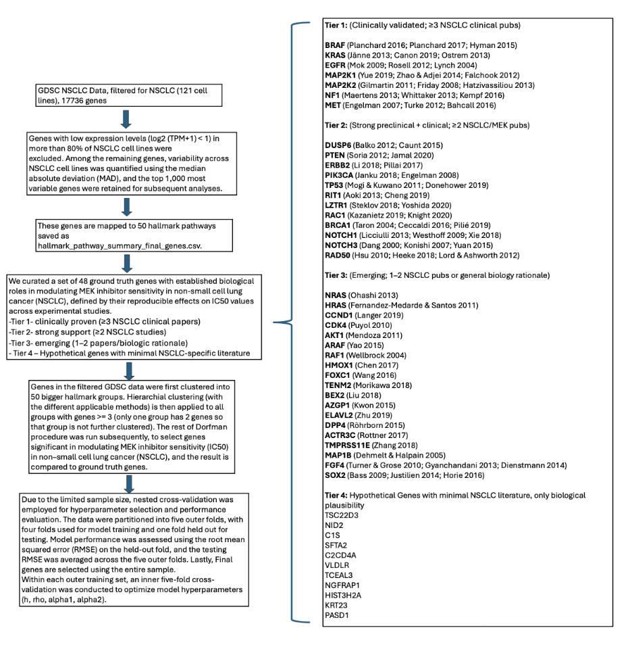

Figure 2. Workflow for selecting and validating genes selected by Dorfman and other competitor methods.

To benchmark model discoveries against established biology, we organized genes into tiered signature sets reflecting the strength of existing evidence linking them to MEK inhibition in NSCLC. Tier 1 (Clinically-Validated) genes were defined as those supported by three or more high-impact, NSCLC-specific clinical publications (e.g., BRAF, KRAS, MAP2K1/2, NF1, MET) directly linking them to **MEK/MAPK response or resistance**. Tier 2 (Strong Preclinical/Clinical) genes were supported by at least two solid studies in NSCLC or closely related MEK-inhibitor contexts (e.g., DUSP6, PIK3CA, PTEN, ERBB2) but not yet fully clinically established. Tier 3 (Emerging Evidence) included genes with limited but suggestive evidence (one to two publications or strong mechanistic rationale), while a final tier captured novel or hypothetical genes with minimal prior NSCLC-specific literature. This tiered structure enabled systematic evaluation of whether data-driven selections recovered known biology while also identifying plausible novel contributors to trametinib response. This resulted in 7 genes in tier 1, 11 genes in tier 2, 19 genes in tier 3 and 11 genes in tier 4. We made sure that the selected genes for each dorfman method is included in the set of genes, grouped based on corresponding evidence.

Due to the limited sample size, nested cross-validation was employed for hyperparameter selection and performance evaluation. The data were partitioned into five outer folds, with four folds used for model training and one-fold held out for testing. Model performance was assessed using the root mean squared error (RMSE) on the held-out fold, and the testing RMSE was averaged across the five outer folds. Lastly, Final genes are selected using the entire sample, using the median of optimal parameters determined by each of the 5 folds. Within each outer training set, an inner five-fold cross-validation was conducted to optimize model hyperparameters (h, rho, alpha1, alpha2) using our developed methods.

Table 4. Comparison of each method on final genes, clinical significance, and prediction RMSE.

|  |  |  |  |  |  |  |  |  |  |  |  |  |
| --- | --- | --- | --- | --- | --- | --- | --- | --- | --- | --- | --- | --- |
| Method | RMSE |  | N_Genes | Genes | Tier1_Hits | Tier2_Hits | Tier3_Hits | Hypothetical genes | Total_Hits | | Clinical Ratio*(see formula) | Clinical_Hits |
| Robust_Dorfman_Adaptive_EN (OGK) | 2.17 |  | 12 | BRAF, DUSP6, AZGP1, FGF4, TSC22D3, ELAVL2, DPP4, HMOX1, FOXC1, NID2, HIST3H2A, C2CD4A | 1 | 1 | 6 | 4 | | 12 | 0.133 | 2 |
| Robust_Dorfman_EN (OGK) | 2.33 |  | 10 | BRAF, KRAS, DUSP6, BEX2, FGF4, DPP4, HMOX1, HIST3H2A, MAP1B, TENM2 | 2 | 1 | 6 | 1 | | 10 | 0.2 | 3 |
| Dorfman_sparse_Adaptive_EN | 2.38 |  | 3 | KRAS, DUSP6, BEX2 | 1 | 1 | 1 | 0 | | 3 | 0.133 | 2 |
| Dorfman_sparse_EN | 2.24 |  | 10 | BRAF, MAP2K1, C1S, BEX2, MAP1B, SFTA2, C2CD4A, AZGP1, TMPRSS11E, VLDLR | 2 | 0 | 4 | 4 | | 10 | 0.133 | 1 |
|  |  |  |  |  |  |  |  |  | |  |  |  |
| Dorfman_EN | 2.43 |  | 7 | MET, BEX2, DPP4, TENM2, TMPRSS11E, SOX2, FOXC1 | 1 | 0 | 6 | 0 | | 7 | 0.067 | 1 |
| Adaptive_LASSO | 2.46 |  | 3 | BEX2, DUSP6, FGF4 | 0 | 1 | 2 | 0 | | 3 | 0.067 | 1 |
| Adaptive_EN | 2.41 |  | 5 | BEX2, DUSP6, TENM2, FGF4, FOXC1 | 0 | 1 | 4 | 0 | | 5 | 0.067 | 1 |
| LASSO | 2.49 |  | 7 | BEX2, DUSP6, DPP4, TENM2, TMPRSS11E, ACTR3C, FOXC1 | 0 | 1 | 6 | 0 | | 7 | 0.067 | 1 |
| EN | 2.51 |  | 5 | BEX2, DUSP6, ACTR3C, FOXC1, TENM2 | 0 | 1 | 4 | 0 | | 5 | 0.067 | 1 |
| SIS_LASSO | 2.84 |  | 18 | ELAVL2, BEX2, NID2  , DUSP6, KRT23  , DPP4, MAP1B, SFTA2, PASD1  , NGFRAP1, AZGP1, TENM2, HMOX1, TCEAL3, TMPRSS11E, ACTR3C, VLDLR, FOXC1 | 0 | 1 | 10 | 7 | | 18 | 0.067 | 1 |

*Clinical relevance ratio 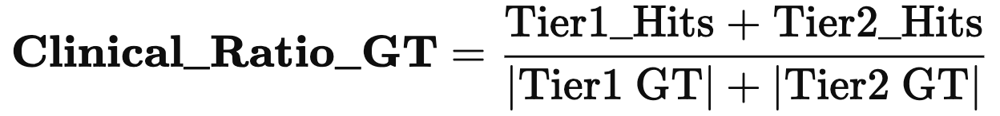, measures how much of the known clinically relevant ground truth (Tier1+2) each method recovers.

(B)

(A)

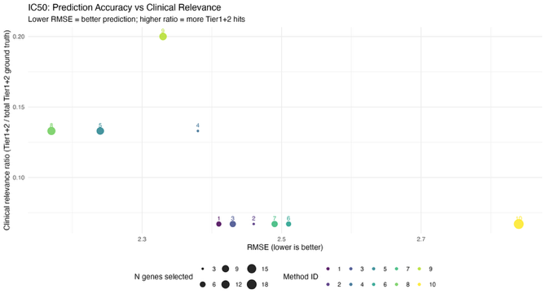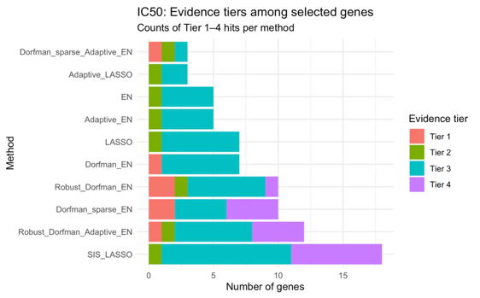

(D)

(C)

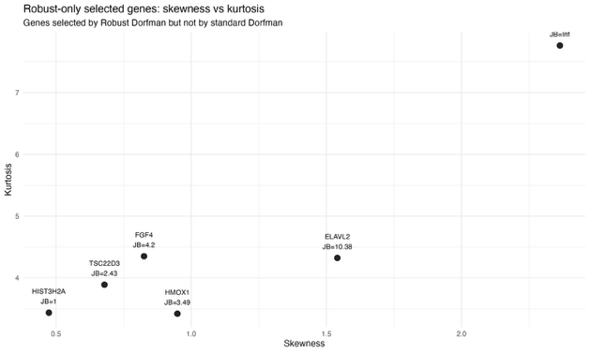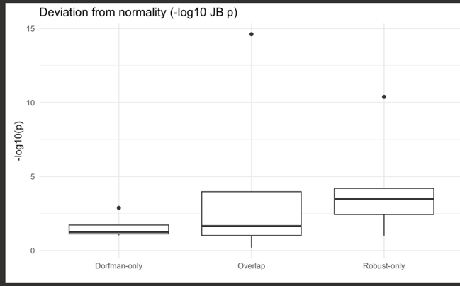

**Figure 3.** Features of genes selected by robust Dorfman methods in comparison to classical Dorfman methods, and in comparison to other methods. (A) **IC50 prediction accuracy vs clinical relevance across gene selection methods.** Each point represents one method, plotted by RMSE (x-axis; lower is better) and the clinical relevance ratio (y-axis; Tier1+Tier2 hits divided by total Tier1+Tier2 ground truth). Point size indicates the number of selected genes. **Method IDs:** 1 = Adaptive_EN, 2 = Adaptive_LASSO, 3 = Dorfman_EN, 4 = Dorfman_sparse_Adaptive_EN, 5 = Dorfman_sparse_EN, 6 = EN, 7 = LASSO, 8 = Robust_Dorfman_Adaptive_EN, 9 = Robust_Dorfman_EN, 10 = SIS_LASSO. Overall, **Robust_Dorfman_EN (ID 9)** provides the strongest clinical enrichment with good prediction accuracy, while **Robust_Dorfman_Adaptive_EN (ID 8)** achieves the best RMSE with strong clinical relevance. While Sparse dorfman methods (Dorfman_sparse_Adaptive_EN and Dorfman_sparse_EN) achieved the same clinical ratio as **Robust_Dorfman_Adaptive_EN, they have higher RMSE and less accurate in prediction. In contrast, Dorfman-EN and adaptive EN exceled neither in RMSE or clinical ratio, while RMSE is worse in vanilla EN and LASSO, with SIS-LASSO being the worst performer.** (B) Bar plot of evidence tiers the genes selected by each method fall into, Red shows tier 1 clinical genes. Dorfman methods consistently select tier 1 genes that other methods fail to, robust Dorfman EN and Dorfman Sparse EN selecting the most tier 1 genes; With adaptive lasso/ EN and vanilla LASSO/EN selecting only tier 2 and 3 genes, In contrast, SIS-LASSO selects the greatest number of genes, but also the most number of tier 4 genes with no prior literature. (C ) Skewness and Kurtosis, along with JB score for genes selected by robust Dorfman methods but missed by traditional Dorfman. JB score is calculated from -log10(JB p-value), where JB statistic =(n/6)*(S^2+((K−3)^2​))/4), n = sample size, S = sample skewness, K = sample kurtosis (**not excess kurtosis**), where 3 is the kurtosis of a normal distribution. Under H0, JB ~ X^2(2). Robust methods picked up genes with extreme deviation of normality e.g. NID (JB ~ inf, meaning p-value ~ 0), and ELAV2 (JB = 10.38), also shown by both higher skewness and kurtosis. (D) JB score (-log(p-value)) of selected genes by Dorfman-only, overlap, and Robust only. There is clearly higher deviation from normality for robust-only selected genes compared to Dorfman-only, **verifying the robustness of our robust-Dorfman methods in picking out informative but non-normal genes.**

Upon examining our IC50 data, we found several deviations from normality - non-normal IC50, outliers, heteroscedity, skewness and kurtosis of gene expressions (Appendix A Supp Fig 2). We employed our top performing methods in both our normal and corrupt scenarios, namely, the robust methods Robust_Dorfman_Adaptive_EN and robust Dorfman EN with sparse correlation derived from OGK estimator, classical methods Dorfman Sparse adaptive EN and Dorfman Sparse EN using the sparse correlation from graphical LASSO, as well as the traditional Dorfman-EN with Pearson correlation (for comparison). Methods we are comparing against are adaptive EN/LASSO, vanilla EN/LASSO and SIS-LASSO.

The final genes selected, clinical significance, and prediction RMSE are shown in Table 4. Across all methods, genes repeatedly selected were enriched for known modulators of MEK inhibitor sensitivity; however, clear differences emerged in both predictive performance and biological interpretability. The robust Dorfman methods achieved the lowest prediction error, with Robust Dorfman–Adaptive Elastic Net yielding the best RMSE (2.17) while selecting a compact set of genes that included multiple Tier 1 and Tier 2 signatures such as BRAF, KRAS, DUSP6, alongside emerging candidates (HMOX1, FOXC1, AZGP1), while achieving second-best clinical ratio, while **Robust_Dorfman_EN (ID 9) is the clear winner as it** provides the strongest clinical enrichment with good prediction accuracy, recovering same signature genes RAF, KRAS, DUSP6 as well as similar emerging genes (HMOX1, FGF4, MAP1B).

While classical Sparse dorfman methods (Dorfman_sparse_Adaptive_EN and Dorfman_sparse_EN) achieved the same clinical ratio as **Robust_Dorfman_Adaptive_EN,** they have higher RMSE and less accurate in prediction. This is a testament to the performance of robust methods under violation of linear assumptions as seen inherently in the data (non-normal IC50, outliers, heteroscedity, skewness and kurtosis of gene expressions). Notably, Robust methods exclusively picked up genes with extreme deviation of normality e.g. NID (JB ~ inf, meaning p-value ~ 0), and ELAV2 (JB = 10.38), also shown by both higher skewness and kurtosis (Fig 3 C), *and have higher JB score than genes selected classical Dorfman methods exclusively* (Fig 3D). Nevertheless, both robust and classical Dorfman models consistently recovered clinically validated tier 1 drivers (BRAF, MAP2K1, KRAS, MET1) with stable inclusion across folds (as in tier 1 ratio and clinical hits, Fig, 3 B), missed by traditional methods. For example, Robust Dorfman-EN recovered both BRAF and KRAS, whereas Dorfman-sparse adaptive -EN recovered KRAS, Dorfman-Sparse EN recovered both KRAS and MAP2K1, and Dorfman-EN revealed MET as tier1 genes. In general, Dorfman methods has a lower RMSE than the rest (2.17 – 2.43), compared to other methods (2.41 – 2.84), with SIS-LASSO having the worst prediction (RMSE=2.84). Notably, adaptive LASSO and adaptive EN still perform better than Vanilla LASSO, EN and SIS-LASSO (2.41-2.46, vs 2.49 – 2.84) in prediction ability due to pathway structure of genes, however failed to excel in terms of clinical ratio.

The two key regulators consistently identified by the Dorfman-based methods, **BRAF** and **KRAS**, exhibit well-characterized and biologically meaningful patterns of trametinib sensitivity in NSCLC. In the GDSC dataset, **BRAF V600E–mutant cell lines display substantially lower trametinib IC50 values** (Iorio et al., 2016); In contrast, **BRAF wild-type NSCLC cell lines show higher and more heterogeneous IC50 values,** consistent with variable pathway activation and the presence of alternative resistance mechanisms (Prahallad et al., 2012). Similarly, **KRAS-mutant cell lines demonstrate intermediate and context-dependent sensitivity to trametinib** (Chen et al., 2020), in line with prior clinical and preclinical evidence that MEK inhibition alone yields heterogeneous responses in KRAS-driven NSCLC (Jänne et al., 2013). MAP2K1 is uniquely discovered by Dorman-Sparse EN is crucial as it is the direct target of MEKi (Flaherty et al., 2012); **MET was uniquely identified by Dorfman_EN**, highlighting that even the non-robust Dorfman framework can recover **biologically meaningful NSCLC drivers**, since **MET signaling is a known resistance and bypass pathway that can modulate response to MEK inhibition** (Engelman et al., 2007; Turke et al., 2012)**.**

Non-dorfman methods (Adaptive EN/ LASSO and Vanilla EN/LASSO) tended to select broader and more heterogeneous gene sets, tier 2 and tier 3 sets with limited enrichment of clinically validated MEK pathway components, missing tier 1 genes completely (Fig 3 B). Although some key regulators such as DUSP6 and BEX2 appeared across multiple approaches, these models exhibited higher RMSE and less alignment with established MEK biology. SIS-LASSO on the other hand selects the greatest number of genes, but also the most number of tier 4 genes with no previous literature in NSCLC or general biology. Our results demonstrate that incorporating structured grouping and robust correlation estimation substantially improves both predictive accuracy and biological relevance. The superior performance of robust Dorfman methods is consistent with our findings in simulation, further validating robust Dorfman methods as the best choice.

**Limitations and Future Directions**

**Extension to ultra-high dimensions.** It is worth mentioning that, when extending to ultra-high dimensions ($p≫n$, e.g., $p=100,000$ ), several changes to the algorithm must be made. Firstly, full Spearman/Pearson correlation matrices are clearly infeasible, and the first step must be replaced by marginal pre-screening based on the top correlations (or Kendall correlations in the robust case) with $Y$  (Fan & Lv, 2008). The retained variables are then partitioned into blocks. Following that we either apply distributed block adaptive graphical lasso on the empirical covariance matrix (normal case) (Witten et al., 2011) or a blockwise OGK estimator (robust case) (Maronna & Zamar, 2002) and hierarchically cluster / dynamically cut within each block. The groups derived for each block could then be merged across blocks via locality-sensitive hashing (LSH) (Andoni & Indyk, 2008), drastically reducing the number of pairwise comparisons for group merging. The resulting groups selected by LSH will be used in steps 2 (group testing), 3 (individual testing), and 4 (penalized regression). This is detailed in Appendix B, Section B.4.

**Parameter optimization in ultra-high dimensions (e.g., $p=100,000$ ).** The graphical lasso penalty parameter $ρ$ , which in simulation settings was optimized by maximizing the Adjusted Rand Index (ARI) when groups are known, must be chosen in ultra-high dimensions by maximizing the average ARI across blocks (Friedman et al., 2008). Because an extensive grid search involves prohibitive computational complexity and still suffers from random discrete jumps for the significance thresholds $α_{1}$  and $α_{2}$ , this often results in suboptimal variable selection results. To overcome this, we propose **Scalable Hyperparameter Optimization for Ultra-High Dimensions** that uses Bayesian hyperparameter optimization (Snoek et al., 2012; Frazier, 2018), which learns a continuous surrogate model of the objective surface via Gaussian Processes and intelligently samples promising hyperparameter combinations, requiring 10–50× fewer evaluations than exhaustive grid search while converging to near-optimal parameters through sequential expected improvement maximization (see Appendix B, Sections B.1–B.3).

**Time Complexity Analysis of Dorfman Screening for Ultra-High Dimensions.** The **Classical Dorfman Screening** algorithm in ultra-high dimensions has a computational complexity dominated by the initial screening and grouping steps. For $p=100,000$ , $n=200$ , the marginal correlation screening step is $O(np)=O(2×{10}^{7})$ . The blockwise adaptive graphical lasso is performed on $K=40$  blocks of size ≈100, each requiring $O(n⋅{\text{block size}}^{2})$  per penalty parameter $ρ$ , leading to $O(40×200×{10}^{4}×∣ρ∣)≈O(8×{10}^{6})$  operations. The LSH-based merging reduces cross-group comparisons from $O(m^{2})$  to $O(m⋅L)$ , where $m≈400$  and $L=3$ , making merging $O({10}^{3})$ . The overall complexity is approximately $O(3×{10}^{7})$  operations, which is feasible with moderate HPC resources.

The **Robust Dorfman Screening** algorithm is more computationally intensive due to robust estimators. Robust marginal screening using Kendall’s τ is $O(n^{2}p)$  in naive form, but can be optimized to $O(nplog⁡n)≈O({10}^{7}log⁡n)$ . The distributed robust graphical lasso with median-of-medians OGK covariance estimation adds a factor of $O(n^{2})$  per block, resulting in $O(60×{200}^{2}×{50}^{2})≈O(6×{10}^{8})$  operations. Robust LSH merging and consensus clustering further increase the cost, leading to an overall complexity of roughly $O({10}^{9})$  operations.

**Feasibility with HPC.** Both algorithms are **feasible with modern High-Performance Computing (HPC) systems**, but the robust version requires significantly more resources. The classical version can be run on a single multi-core node with 32–64 GB RAM, completing in minutes to hours. The robust version, due to its $O(n^{2})$  components and distributed consensus steps, benefits greatly from parallelization across many nodes and GPU acceleration for covariance estimation. With HPC, the robust algorithm can be executed in a few hours by leveraging distributed computing frameworks (e.g., MPI, Spark) and optimized linear algebra libraries. Memory requirements are manageable ($∼$ 100 GB) due to blockwise processing and sparse representations. Thus, while the robust method is computationally demanding, it remains practical in an HPC environment for $p=100,000$ , $n=200$ .

## **5. Conclusion**

Our results demonstrate that robust-OGK-Dorfman-Adaptive EN/ EN as the method of choice for feature selection of high-dimensional, group correlated data. In simulations across normal and corrupt scenarios, robust Dorfman consistently outperformed competitors, while exhibiting lowest RMSE and highest clinical relevance ratio in selecting genes in NSCLC cell lines whose expression most predicts IC50 for trametinib. This method, albeit promising, we do acknowledge modifications for extension to ultra-high dimension (e.g. p=100,000) variable selection, including incorporating improvements in the first step such as block OGK, block graphical lasso, and LSH in group merging as well as Bayesian optimized hyperparameter selection, with use of HPC clusters.

**References**

**Andoni, A., & Indyk, P.** (2008). Near-optimal hashing algorithms for approximate nearest neighbor in high dimensions. Communications of the ACM, 51(1), 117–122.

Fan, J., & Lv, J. (2008). **Sure independence screening for ultrahigh dimensional feature space.** Journal of the Royal Statistical Society: Series B, 70(5), 849–911.

**Frazier, P. I.** (2018). A tutorial on Bayesian optimization. arXiv preprint arXiv:1807.02811.

Bühlmann, P., & van de Geer, S. (2011). **Statistics for High-Dimensional Data.** Springer.

Fan, J., Samworth, R., & Wu, Y. (2009). **Ultrahigh dimensional feature selection: Beyond the linear model.** Journal of Machine Learning Research, 10, 2013–2038.

Barabási, A.-L., & Oltvai, Z. N. (2004). **Network biology: understanding the cell’s functional organization.** Nature Reviews Genetics, 5(2), 101–113.

Subramanian, A., et al. (2005). **Gene set enrichment analysis: A knowledge-based approach for interpreting genome-wide expression profiles.** PNAS, 102(43), 15545–15550.

Zou, H., & Hastie, T. (2005). **Regularization and variable selection via the elastic net.** Journal of the Royal Statistical Society: Series B, 67(2), 301–320.

Meinshausen, N., & Bühlmann, P. (2010). **Stability selection.** Journal of the Royal Statistical Society: Series B, 72(4), 417–473.

**Maronna, R. A., & Zamar, R. H.** (2002). Robust estimates of location and dispersion for high-dimensional datasets. Technometrics, 44(4), 307–317.

**Snoek, J., Larochelle, H., & Adams, R. P.** (2012). Practical Bayesian optimization of machine learning algorithms. Advances in Neural Information Processing Systems, 25.

Fan, J., & Song, R. (2010). **Sure independence screening in generalized linear models with NP-dimensionality.** The Annals of Statistics, 38(6), 3567–3604.

Wang, H. (2009). **Forward regression for ultra-high dimensional variable screening.** Journal of the American Statistical Association, 104(488), 1512–1524.

**Simon, N., Friedman, J., Hastie, T., & Tibshirani, R. (2013).** A sparse-group lasso.  
**Journal of Computational and Graphical Statistics, 22(2), 231-245.**

Li, R., Zhong, W., & Zhu, L. (2012). **Feature screening via distance correlation learning.** Journal of the American Statistical Association, 107(499), 1129–1139.

He, X., Wang, L., & Hong, H. G. (2013). **Quantile-adaptive sure independence screening for high-dimensional heterogeneous data.** The Annals of Statistics, 41(1), 342–369.

Shao, J., & Zhang, C.-H. (2014). **Support recovery in high-dimensional linear regression.** The Annals of Statistics, 42(6), 2228–2256.

Zhao, S. D., & Li, Y. (2012). **Principled sure independence screening for Cox models with ultra-high-dimensional covariates.** Journal of Multivariate Analysis, 105, 397–411.

Tibshirani, R. (1996). **Regression shrinkage and selection via the LASSO.** Journal of the Royal Statistical Society: Series B, 58(1), 267–288.

**Fan, J., & Fan, Y. (2008).** High-dimensional classification using features annealed independence rules. Annals of Statistics, 36(6), 2605-2637.

**Kepplinger, D. (2021).** Robust Variable Selection and Estimation Via Adaptive Elastic Net S-Estimators for Linear Regression. Department of Statistics, School of Computing, George Mason University.

**Zhao, P., & Yu, B. (2006).** On model selection consistency of Lasso. Journal of Machine Learning Research, 7, 2541-2563.

**Zou, H. (2006).** The adaptive Lasso and its oracle properties. Journal of the American Statistical Association, 101(476), 1418-1429.

Yuan, M., & Lin, Y. (2006). **Model selection and estimation in regression with grouped variables.** Journal of the Royal Statistical Society: Series B, 68(1), 49–67.

Huang, J., Breheny, P., & Ma, S. (2010). **Group selection in high-dimensional models.** Statistical Science, 25(2), 192–215.

Simon, N., Friedman, J., Hastie, T., & Tibshirani, R. (2013). **A sparse-group LASSO.** Journal of Computational and Graphical Statistics, 22(2), 231–245.

Jacob, L., Obozinski, G., & Vert, J.-P. (2009). **Group LASSO with overlap and graph LASSO.** Proceedings of ICML, 433–440.

**Witten, D. M., Friedman, J. H., & Simon, N.** (2011). New insights and faster computations for the graphical lasso. Journal of Computational and Graphical Statistics, 20(4), 892–900.

Bühlmann, P., Kalisch, M., & Meier, L. (2014). **High-dimensional statistics with a view toward applications in biology.** Annual Review of Statistics and Its Application, 1, 255–278.

Fan, J., Li, R., Zhang, C.-H., & Zou, H. (2012). **Statistical foundations of data science.** Statistica Sinica, 22, 1231–1263.

Alfons, A., Croux, C., & Gelper, S. (2013). **Sparse least trimmed squares regression for analyzing high-dimensional large data sets.** The Annals of Applied Statistics, 7(1), 226–248.

• **Dorfman, R.** (1943). The detection of defective members of large populations. **The Annals of Mathematical Statistics**, 14(4), 436–440.

• **Friedman, J., Hastie, T., & Tibshirani, R.** (2008). Sparse inverse covariance estimation with the graphical lasso. **Biostatistics**, 9(3), 432–441.

• **Huber, P. J.** (1964). Robust estimation of a location parameter. **The Annals of Mathematical Statistics**, 35(1), 73–101.

**Tatsuoka, K., & Chen, W.** (2023). Bayesian group testing with dilution effects. **Biostatistics**, 24(4), 885–902.

Oellerer, V., & Croux, C. (2015). *Robust high-dimensional precision matrix estimation.*  
**Statistics and Computing**, 25(1), 237–250.

Qiu, D., & Ahn, J. (2020). *Grouped variable screening for ultra-high dimensional data for linear model*. Computational Statistics & Data Analysis, 144, 106894.

Langfelder, P., Zhang, B., & Horvath, S. (2008). *Defining clusters from a hierarchical cluster tree: The Dynamic Tree Cut package for R*. Bioinformatics, 24(5), 719–720.

**Chen, H. et al.** (2020). KRAS mutation-induced metabolic reprogramming shapes the response to MEK inhibition in NSCLC. Cancer Research, 80(12), 2538–2550.

**Engelman, J. A. et al.** (2007). MET amplification leads to gefitinib resistance in lung cancer by activating ERBB3 signaling. Science, 316(5827), 1039–1043.

**Flaherty, K. T. et al.** (2012). Combined BRAF and MEK inhibition in melanoma with BRAF V600 mutations. New England Journal of Medicine, 367(18), 1694–1703.

**Iorio, F. et al.** (2016). A landscape of pharmacogenomic interactions in cancer. Cell, 166(3), 740–754.

**Jänne, P. A. et al.** (2013). Selumetinib plus docetaxel for KRAS-mutant advanced non-small-cell lung cancer: A randomised, multicentre, placebo-controlled, phase 2 study. The Lancet Oncology, 14(1), 38–47.

**Prahallad, A. et al.** (2012). Unresponsiveness of colon cancer to BRAF(V600E) inhibition through feedback activation of EGFR. Nature, 483(7387), 100–103.

**Turke, A. B. et al.** (2012). Preexistence and clonal selection of MET amplification in EGFR mutant NSCLC. Cancer Cell, 17(1), 77–88.

**Appendices**

**Appendix A: Supplementary Figures and performance metrics**

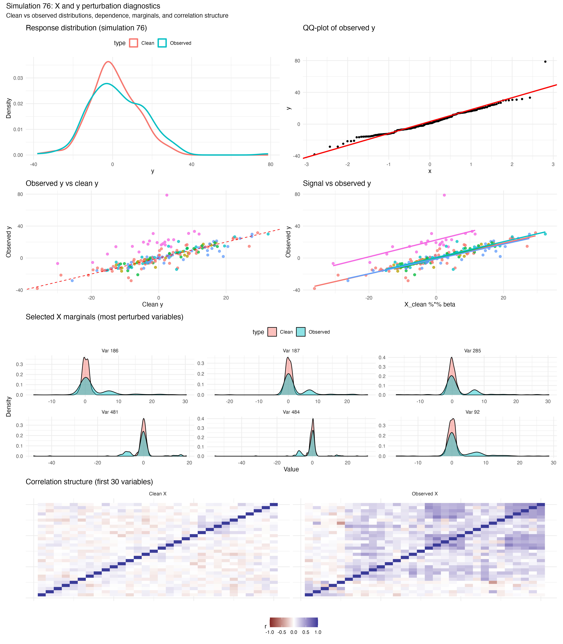

(A)

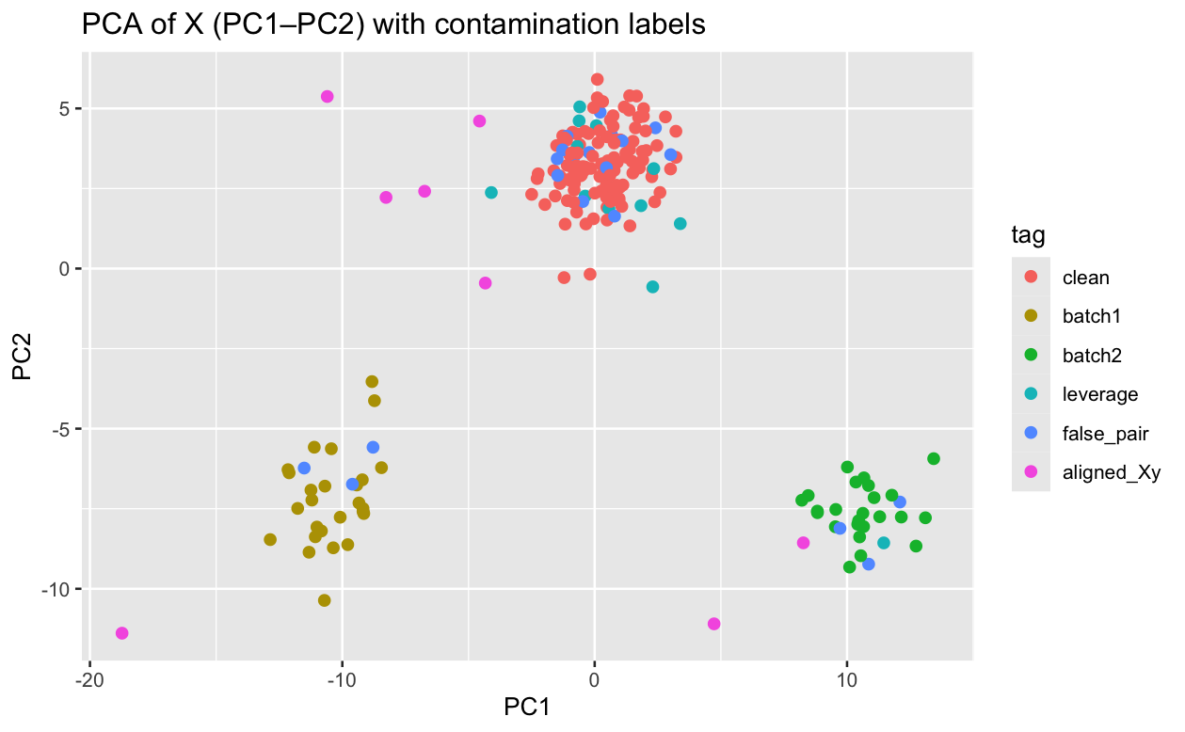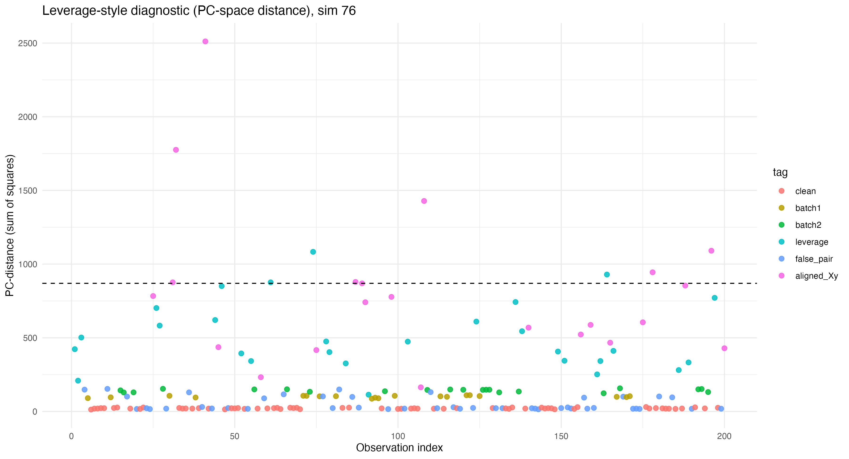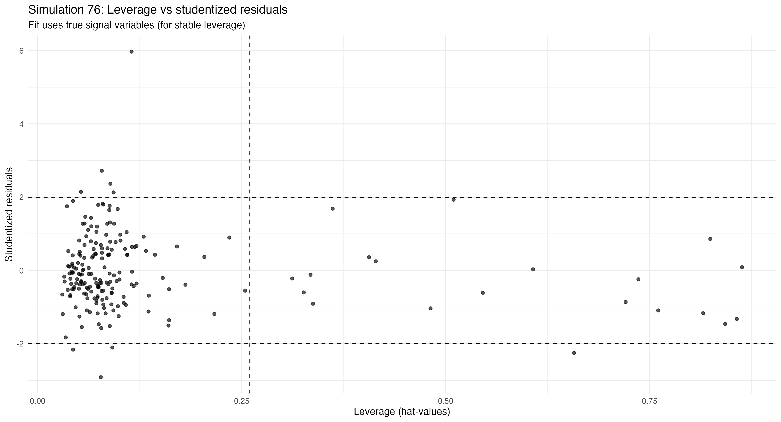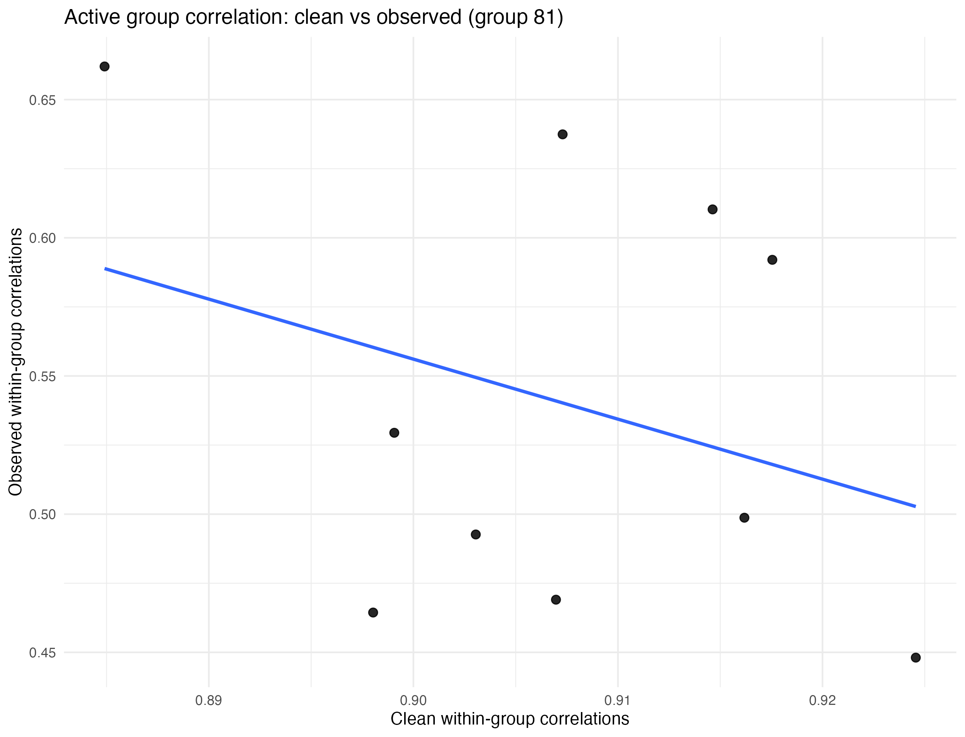

(D)

(C)

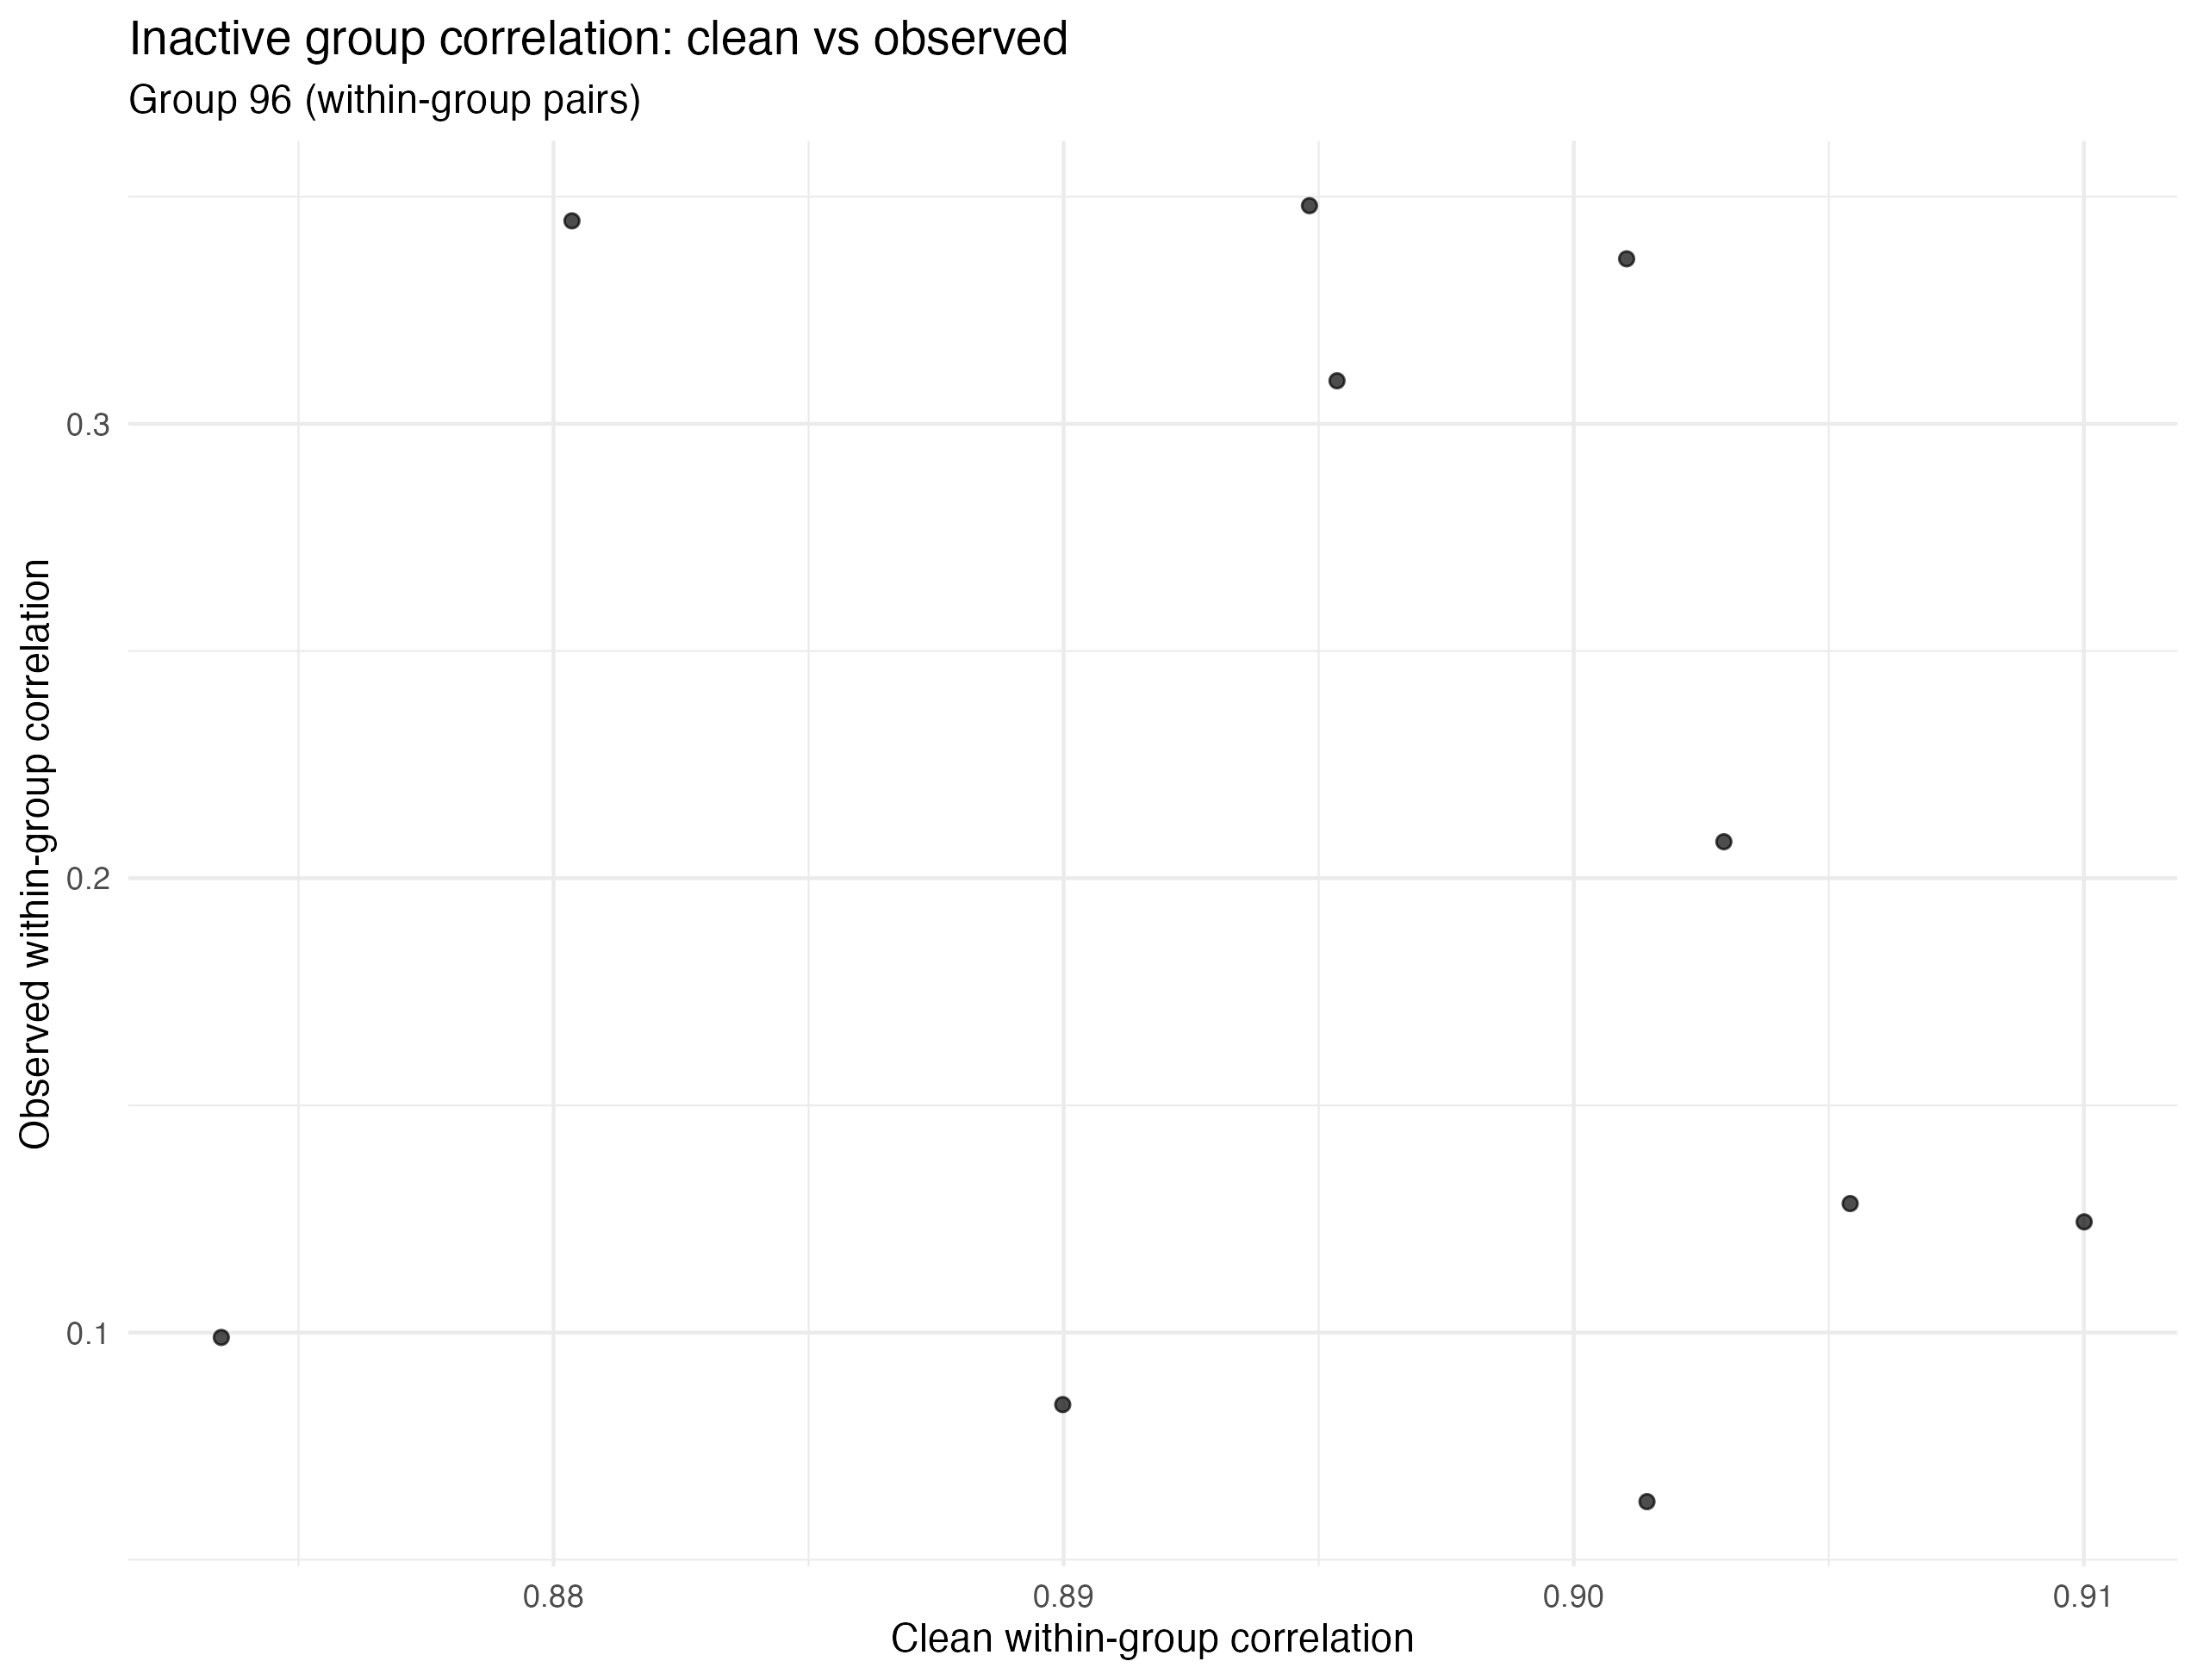

Supplementary Fig 1. Diagnostic plots of corrupted data. (A) QQ Plots, Skewness and Kurtosis plots, and correlation plots. It is seen that the corrupted data had outliers, deviation from normality, and homodesctic errors. The correlations within group for the first 30 variables are shown, in the clean simulation, all correlations are 0.1 (left). However, in the corrupted case, all correlations are in 0.5-1 range. (B) PCA plot of X in the corrupted simulation, batch effects are clearly visible. (C) High residual and leverage points are clearly shown (D) Both group 81 and 96 have within group correlation of 0.9, however the corrupted correlations are in the range of 0.45-0.65 and 0.1-0.3 respectively.

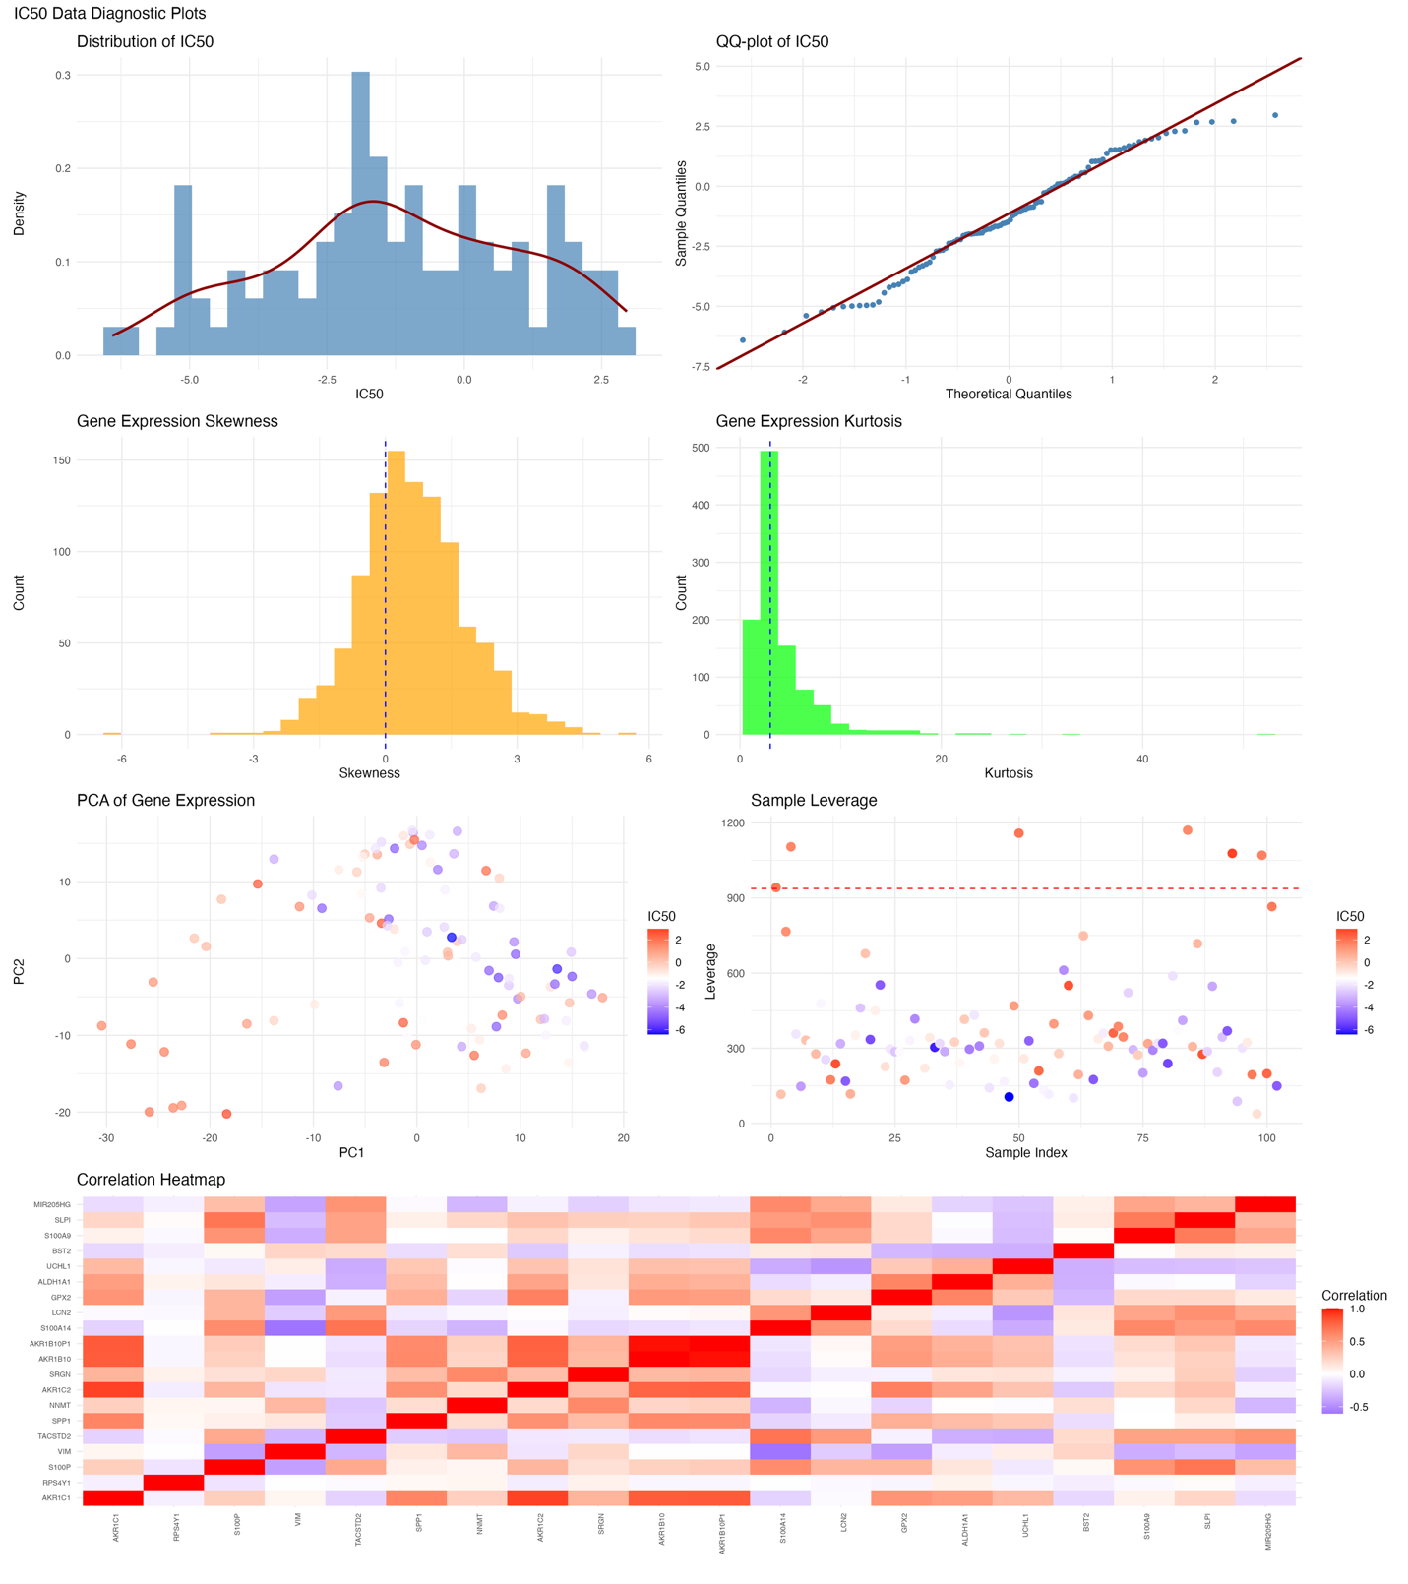

Supplementary Fig 2. Diagnostic plots of trametinib IC50 data. IC50 distribution and QQ plots clearly show outliers and non-normality. Gene expression data clearly show kurtosis, skewness, and high leverage points.

